Developing Embodied Awareness: A short residential course
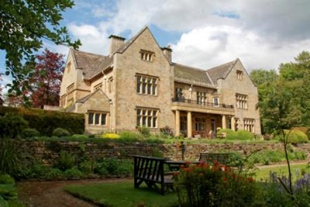
Sunday 19th to Tuesday 22nd November 2017, Shepherds Dene, Riding Mill, Northumberland

Designed to be of practical value to psychotherapists, psychologists, psychiatrists and mental health practitioners for their work and for their self-care, this short course aims to provide a stimulating and refreshing forum for the development of embodied awareness: our own, our patients’ and the relational dances that we experience in our practice.

In the past ten years we have seen a remarkable convergence upon the importance of the body in psychotherapy. There are many specialist trainings for working with the body in a more active way, especially in the trauma field, but not all mainstream trainings have adapted to include theoretical and methodological approaches to embodiment in its most general sense – how we experience each other through our bodies as much as through the sharing of our minds.

The aim of this course is to bring our attention to the non-verbal dialogue unfolding within our sessions, how we are literally moved in relationship with our patients. We will begin to understand how we experience this dance within our bodies and how we regulate ourselves through this embodied experience, in the moment within the session and over longer time periods in our careers. The theme of self-care will be a focus of the course, learning how to attend to our physical self-care in the face of our prolonged engagement with patients experiencing and communicating embodied distress.

The sessions will be experiential in nature, working in dyads and small groups to promote self-reflection and self-awareness. Theory will be woven into the work and written material made available before and after the course but the focus will not be a theoretical one. The emphasis will be practical. We will investigate how attention to proximity, rhythm, posture, gesture and micro movements might inform and enrich our work and support our self-care.

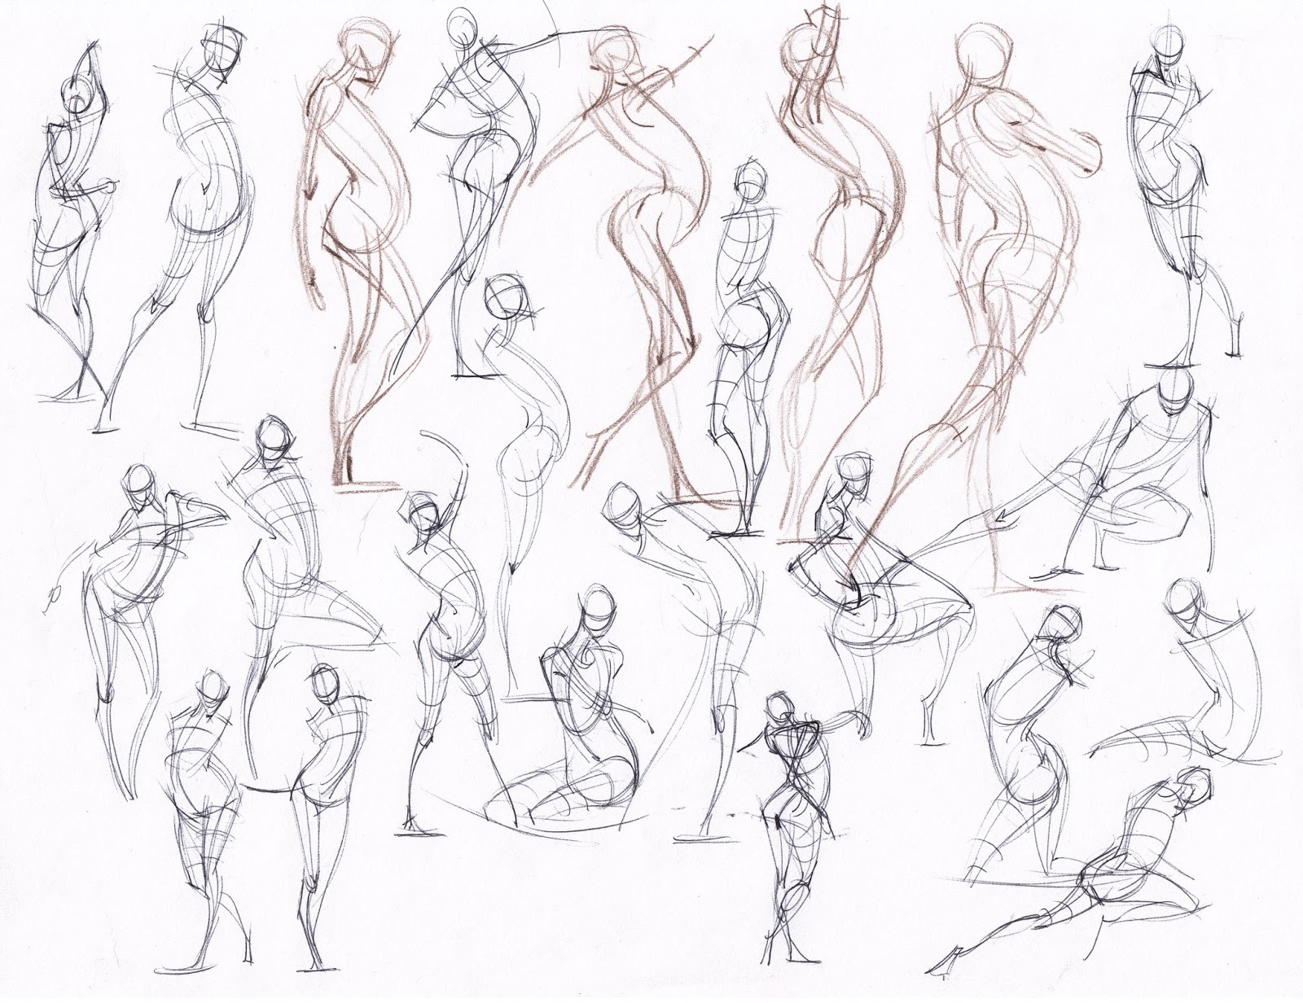
The overarching theoretical frame for the course is relational psychotherapy. I will present an integration of specialist training in Development Somatic Psychotherapy, a Gestalt model developed in the USA by Ruella Frank which explores the links between developmental movement patterns and psychological functioning, and Cognitive Analytic Therapy as a frame for collaborative and dialogic understanding of relational patterns. The integration is intended to provide a direct and clear language for embodied communication that is useful and applicable to a UK context and the everyday practice of psychological therapy in the NHS and other settings. Familiarity with these models is not a prerequisite and pre-reading will be distributed in advance.

By the end of the workshop participants will
- Have a broad overview of different approaches to working with the body in psychotherapy
- Gain specific familiarity with the Developmental Somatic model, which emphasises how affective/ movement patterns between infant and caregiver influence psychological development, and explores how this is lived in the present moment between therapist and patient
- Explore their own developmental movement patterns and deepen their experience of their own body in relationship
- Learn skills of enquiry into body process for themselves and their patients and tools for supervision/ self-supervision
- Gain insight into how to apply an informed body process to feel more resourced, whole and protected

There will be a total of 14 hours of facilitated teaching between Sunday at 4pm and Tuesday at 4pm.

Who is the course for?

The course is open to all professionals with a core training in any modality of psychological therapy, working in all patient groups and settings. No prior experience of body-based theories or methodologies is required. As the course will be largely experiential in nature it is important the participants have previous experience of engaging in their own counselling, psychotherapy or reflective practice groups. If you have any questions about the relevance of your background and training please do get in touch.

Pre-reading material will be sent out in September.

Caroline Dower is an Integrative Psychotherapist with training backgrounds in Cognitive Analytic Therapy, Integrative Psychotherapy and Developmental Somatic Psychotherapy. Caroline is the Head of Service at Durham University, and trains and supervises therapists across a range of NHS and private settings.

Venue

Shepherd’s Dene is a retreat centre 30 minutes away from the rail and air links of Newcastle. It is a beautiful Arts and Crafts house set in 20 acres of grounds. The cost includes accommodation in single occupancy rooms, breakfast, lunch, dinner and refreshments during the breaks. All food is home-produced and locally supplied. A bar is available in the evenings. Special dietary requirements can be catered for, with advance notice, and the building is fully accessible.

Car parking is available on-site and for those arriving into Newcastle by rail or air please do let me know and I will try to put you in touch with other participants to coordinate transfers to the centre.

Link to the venue: www.shepherdsdene.co.uk

Booking and cancellations policy

The full cost of the course, accommodation for two nights and full board is £300. Places can be booked for a deposit of £50. Cheques payable to C Dower or via internet banking account 89672593, sort code 60 04 23. Please do add your surname and the words ‘Course deposit’ to the reference if paying online and return the booking form direct to me at carolinedower@hotmail.com or to the address on the form.

There are only 10 places available for the full residential, due to demands on space at Shepherds Dene. If any local delegates are happy to attend only as a day delegate, but join us for the meals, the reduced rate would be £220.

The full balance is payable by 30 September 2017.
Full refunds minus £50 deposit paid for cancellations before 30 September 2017.
50% refund for cancellations between 1 October and 31 October 2017.

Enquiries

Please do not hesitate to get in touch either on carolinedower@hotmail.com or 07974 836436.

Outline Programme – detail may change

Day 1: Sunday 19th November

Arrival from 3pm, tea and cake available

4pm-6pm Session 1 Check-in and introductions
Principles and key influences, orientation of the course
The body in relationship and dialogue, and the links between
movement and psychological function

6.30pm Dinner

8pm-9pm Session 1 (cont’d)

Day 2: Monday 20th November

8.30am Breakfast

9.30-12.30 Session 2: Yielding – the capacity to be with and find support
11am Coffee

12.30 – 2pm Lunch

2pm -3.30pm Session 3: Lecture: An overview lecture of the history of the body in
psychotherapy, how it has been conceptualized and addressed

3.30pm Tea

4pm – 6pm Session 4: Pushing – separating from the Other whilst including the
Other, discovering and making difference

6.30pm Dinner

8pm-9pm Session 5: Boundaries – bringing yield and push together in a
somatic exploration of the concept, balancing our connectedness/
involvement and our separateness

Day 3 Tuesday 21st November

8.30am Breakfast

9.30-11am Session 6: Dimensions of movement/ relationality
Horizontal/ Vertical/ Sagittal dimensions as links between physical,
emotional and cognitive domains.

11am Coffee

11.30-12.30 Session 7: Sustaining our practice
Applying embodied awareness to our self-reflection, supervision and
self-care

12.30 – 2pm Lunch

2pm -3.30pm Session 8: Integration, closing remarks and goodbyes
3.30 – 4pm Tea

Total of 14 hours of facilitated teaching input

Booking Form:
Embodied Awareness, 19th-21st November 2017
Shepherd’s Dene

Name
Address
Email
Contact telephone numbers
Preferred form (Delete as applicable) | Full course including accommodation, or  Day delegate
Dietary requirements

Accessibility requirements

Travel to/from venue
(Will try to link participants arriving by rail or air)

Current work role

Training background

Experience of own counselling/ psychotherapy?
Modality / frequency/ duration

The full cost for the course, accommodation for two nights and full board is £300. A deposit of £50 will secure a place.
A reduced day rate of £220 includes all teaching and meals, but not overnight accommodation.

Cheques payable to C Dower or via internet banking account 89672593, sort code 60 04 23. Please do add your surname and the words ‘Course deposit’ to the reference if paying online and return the booking form direct to me at carolinedower@hotmail.com or to

C Dower
Granville
Percy Terrace
Durham
DH1 4DY

The full balance is payable by 30 September 2017.

Cancellation policy
Full refunds minus £50 deposit paid for cancellations before 30 September 2017.
50% refund for cancellations between 1 October and 31 October 2017.

