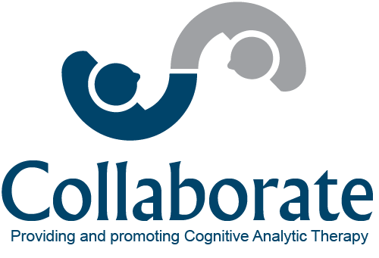

Two-day Introduction to

Cognitive Analytic Therapy

Thursday 26th September and Friday 27th September 2019
CAMBRIDGE
9.30am to 4.30pm each day, lunch included
Facilitated by Dr Alison Jenaway, Dr Carol Gregory and Rosemary Parkinson

This course teaches the basics of Cognitive Analytic Therapy (CAT). Through a combination of lectures and clinical exercises you will learn how to use CAT ideas with individuals and teams.
A CAT understanding of how people relate to each other is helpful in a variety of roles and settings, however, this course will be particularly relevant to those working as therapists and in teams. It is based on a popular course run for many years within Cambridge and Peterborough Mental Health Foundation Trust.

The course will take place in the Collaborate training room at the University Staff Counselling Service, 2-3 Bene’t Place, Cambridge CB2 1EL. This is walking distance from the central Cambridge train station. Parking is available in the Grand Arcade car park.

There is a fee of £160 for the 2-day course for online bookings.
For payment by cheque or increase the fee is £175
Any queries please contact us on contact@collaborate.me.uk
Or call Alison Jenaway on 07771 595594.
To book, please go to the ACAT website at acat.me.uk

