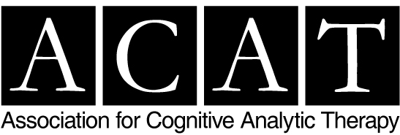

Booking Form

ACAT Introducing Cognitive Analytic Therapy – Two Day Online Workshop
Thursday 24th and Friday 25th November 2022
□ please invoice my employer £205 (purchase order must be attached with this form)

Full Name:
Job Title:
Address:

Contact No:
Email:
Do you have any special requirements? Please give details: …………………………………………………………………………………………

A Purchase Order MUST BE ATTACHED TO THIS BOOKING FORM WHEN SUBMITTED TO ACAT PLEASE; THANK YOU.

Refund Policy: A refund, less a £25 administration fee, will be made if cancellations are received, in writing, at least four weeks before the event. We regret that any cancellation after this time cannot be refunded, and refunds for failure to attend the event cannot be made.

Data Protection: For the purposes of the Data Protection Act 1998, the data controller in respect of your personal data is the Association for Cognitive Analytic Therapy. Your data will be used to administer the event to which you have subscribed.

For full terms and conditions please visit www.acat.me.uk/page/acat+events+terms+and+conditions

Please email the completed form with your purchase order to alison.marfell@acat.me.uk

